LAB 10 (Collection Frames)

1.

package com.company;  
  
import java.util.\*;  
class Palindrome{  
 public static void main(String args[]){  
  
 ArrayList<String> a=new ArrayList<String>(); a.add("john");  
 a.add("racecar");  
 a.add("tenet");  
 a.add("madam");  
 a.add("tears"); for(String str:a)  
 {  
 String reverse=""; int len=str.length();  
 for(int i=len-1;i>=0;i--)  
 reverse=reverse+str.charAt(i); if(str.equals(reverse))  
 System.*out*.println(str);  
 }  
 }  
}

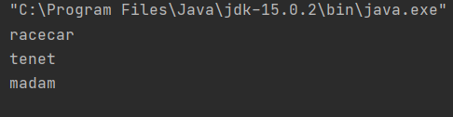

2.

import java.util.\*; class Statistics  
{  
 public static void main(String args[])  
 {  
 Scanner in=new Scanner(System.*in*); ArrayList<Float> arr=new ArrayList<Float>(); float n;  
 System.*out*.println("Enter 5 no: "); for(int i=0;i<5;i++)  
 {  
 n=in.nextFloat(); arr.add(n);  
 }  
 float sum=0; float mean; float tmp; for(Float x:arr)  
 {  
 sum=sum+x;  
 }  
 mean=sum/arr.size();  
  
 for(int i=0;i<arr.size();i++)  
 {  
 for(int j=0;j<arr.size()-i;j++)  
 {  
 if(j+1!=arr.size())  
 {  
 if(arr.get(j)>arr.get(j+1))  
 {  
 tmp=arr.get(j); arr.set(j,arr.get(j+1)); arr.set(j+1,tmp);  
 }  
 }  
 }  
 }  
  
 float median=0; float mid=0; if(arr.size()%2 == 0)  
 {  
 int temp=(arr.size()/2)-1; for(int i=0;i<arr.size();i++)  
 {  
 if(temp==i || (temp+1)==i)  
 {  
 mid=mid+arr.get(i);  
 }  
  
 }  
 mid=mid/2;  
 }  
  
 else  
 {  
  
  
  
  
  
  
  
  
 }  
  
  
  
 int temp=(arr.size()/2); for(int i=0;i<arr.size();i++)  
 {  
 if(temp==i)  
 {  
 mid=arr.get(i);  
 }  
 }  
  
//System.out.println(arr);  
  
  
 int[] count=new int[arr.size()]; for (int i = 0; i < arr.size(); i++)  
 {  
 for(int z=i+1;z<arr.size();z++)  
 {  
 if(arr.get(i)-arr.get(z)==0)  
 {  
 count[i]=count[i]+1;  
 }  
 }  
 }  
 int maxCount = 0; float mode=0;  
 for (int i = 0; i <arr.size(); i++)  
 {  
 if (count[i] >= maxCount)  
 {  
 maxCount = count[i]; mode = arr.get(i);  
 }  
 }  
 arr.add(mean); arr.add(mid); arr.add(mode);  
 System.*out*.println(arr);  
 }  
}

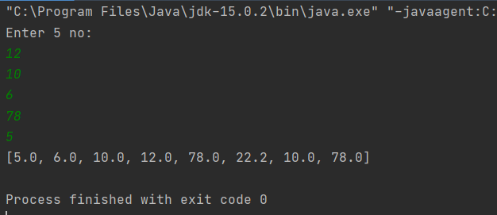

3.

package com.company;  
  
import java.util.\*;  
class Bank  
{  
 int accno;  
 String name,branch; double bal;  
 Bank(int accno,String name,String branch,double bal)  
 {  
 this.accno=accno; this.name=name; this.branch=branch; this.bal=bal;  
 }  
 public static void main(String[] args)  
 {  
 Scanner in=new Scanner(System.*in*); ArrayList<Bank> Custumer = new ArrayList<Bank>(); Bank b1=new Bank(111,"John","Chetpet",696900);  
 Bank b2=new Bank(222,"Sajana","Anna Nagar",20000);  
 Bank b4=new Bank(444,"Wick","Anna Nagar",40000);  
 Bank b6=new Bank(666,"Peter","Anna Nagar",60000);  
 Bank b8=new Bank(888,"Jake","Anna Nagar",80000);  
 Bank b10=new Bank(999,"Chandler","Anna Nagar",100000); Custumer.add(b1);  
 Custumer.add(b2); Custumer.add(b4); Custumer.add(b6); Custumer.add(b8); Custumer.add(b10);  
 Iterator itr=Custumer.iterator(); while(itr.hasNext())  
  
 {  
 Bank b=(Bank)itr.next(); if(b.bal>50000)  
 { System.*out*.println("=====================================================================");  
 System.*out*.println(" Account number:"+b.accno+"\n Name:"+b.name+" \n Bank Branch:"+b.branch+" \n Balance:"+b.bal);  
 }  
 } System.*out*.println("=====================================================================");  
 int c; double S=0;  
 System.*out*.println("Total Ammount in Branch 1)Anna Nagar 2)Chetpet"); c=in.nextInt();  
 Iterator itr2=Custumer.iterator(); while(itr2.hasNext())  
 {  
 Bank b=(Bank)itr2.next(); if(c==1)  
 {  
 if(b.branch=="Anna Nagar") S=S+b.bal;  
 }  
 if(c==2)  
 {  
 if(b.branch=="Chetpet") S=S+b.bal;  
 }  
 }  
 System.*out*.println("The Total Balance is:"+S);  
 }  
}

